Chapter 16, Problem 35.

Find v_{o}(t) in the circuit in Fig. 16.58.

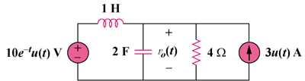

Figure 16.58
For Prob. 16.35.

